

Task 1

Saif Khatatbeh/ Adeeb Shaban/ Eskander Ziadat



**I. Registering the domain name process**

To register a domain name, you will need to do the following steps: (Website.com)

Firstly, choose a domain name (in this case our names).

Then, there’s some information you need to provide the registrar, and they are: (Website.com)

1. The chosen domain names.
2. Name of the person that requested the registration, his email, phone number, the physical address (Address + zip code), the administrative and billing contacts.
3. The registration term for the domain name registration
4. Payment information such as: billing info, card number, CVV.

After submitting this information: (Website.com)

1. The registry will start the domain name registration process for your request.
2. The registrar will send your chosen name request and then contacting the technical information of your domain name to the registry.
3. The registry files the contact information for the Whois which is lookup for the IP address.
4. The registry will store the domain name zone files in the master servers (Their database)
5. The master server will contact other servers that is connected to the internet and tells where the website is stored

And then, when all information is updated, the domain will be considered and registered as ready-to-use. Here is a simple dialogue that will summarize the registration process.

(icann, 2017).

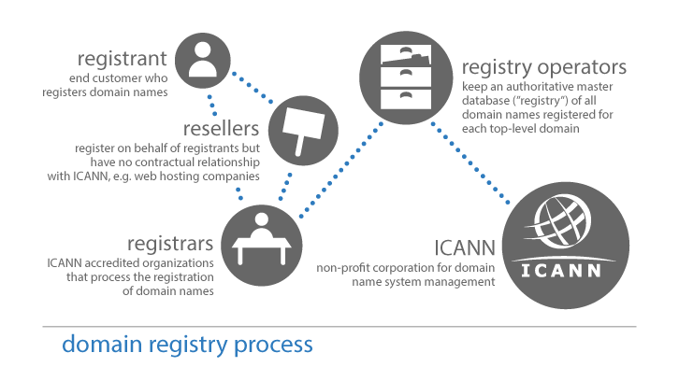

**II. Here is how we registered our own name:**

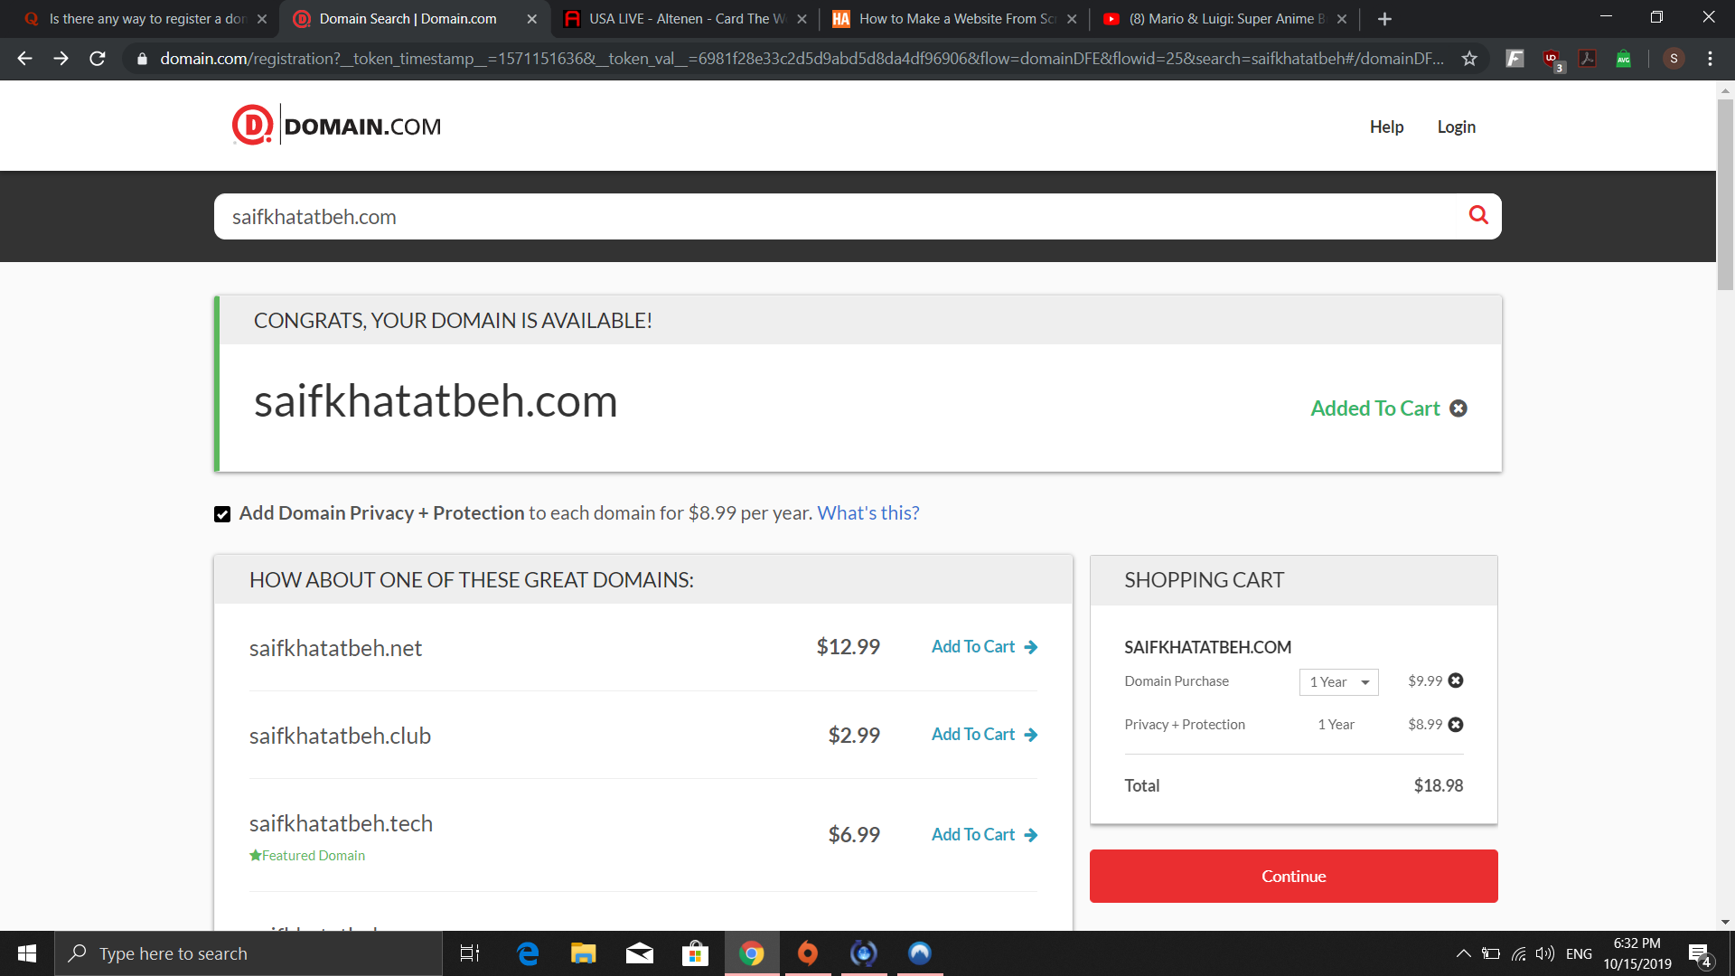

There are many ways to register a domain name, the simplest one is buying a custom domain name from a third party website, in this case we used Domain.com

**III. Difference between domain names:**

* Why there are different domain names extensions?

The domain name that you have is your identity over the World Wide Web. It’s something that determines your existence on the web. Getting the ideal domain name depend on the market and on the audience that you are trying to reach. (Erik, 2013)

* There are many domain name extensions, here are the most common ones: (Quackit)

|  |  |
| --- | --- |
| Domain | Purpose |
| .com | The most common and recognized around the globe, it’s used by companies or individuals that want a global presence. |
| .org | Extensions that is used by the organizations and non- profit organizations also tend to use them as its perfect for them |
| .net | Commonly Used by computer technology companies, service providers, network services. |
| .edu | Commonly used for educational purposes. |
| .jo /.ru/.uk | to indicate the country of the website |

# Bibliography

**Domain Name Extension Definitions** [Online] / auth. Quackit // Quackit. - https://www.quackit.com/domain-names/domain_name_extension_definitions.cfm.

**Domain Name Registration Process** [Online] / auth. icann whois // whois icann. - July 2017. - https://whois.icann.org/en/domain-name-registration-process.

**Registering a Domain Name** [Online] / auth. Website.com // Website.com Learning center. - https://www.website.com/beginnerguide/registeringdomain/4/9/domain-name-registration-process.ws.

**Why Do You Need To Register Multiple Domain Extensions For your Business Website?** [Online] / auth. Erik // eukhost. - Jul 11, 2013. - https://www.eukhost.com/blog/webhosting/why-do-you-need-to-register-multiple-domain-extensions-for-your-business-website/.